UNIVERSITY OF GHANA
DEPARTMENT OF COMPUTER SCIENCE

DCIT 204/308: Data Structures and Algorithms I & II

Joint DSA Semester Project
Ghana Smart Service Operations Optimizer

A practical project integrating algorithm design, empirical analysis, linear and hierarchical data structures, graph algorithms, database storage, correctness testing and performance reporting.

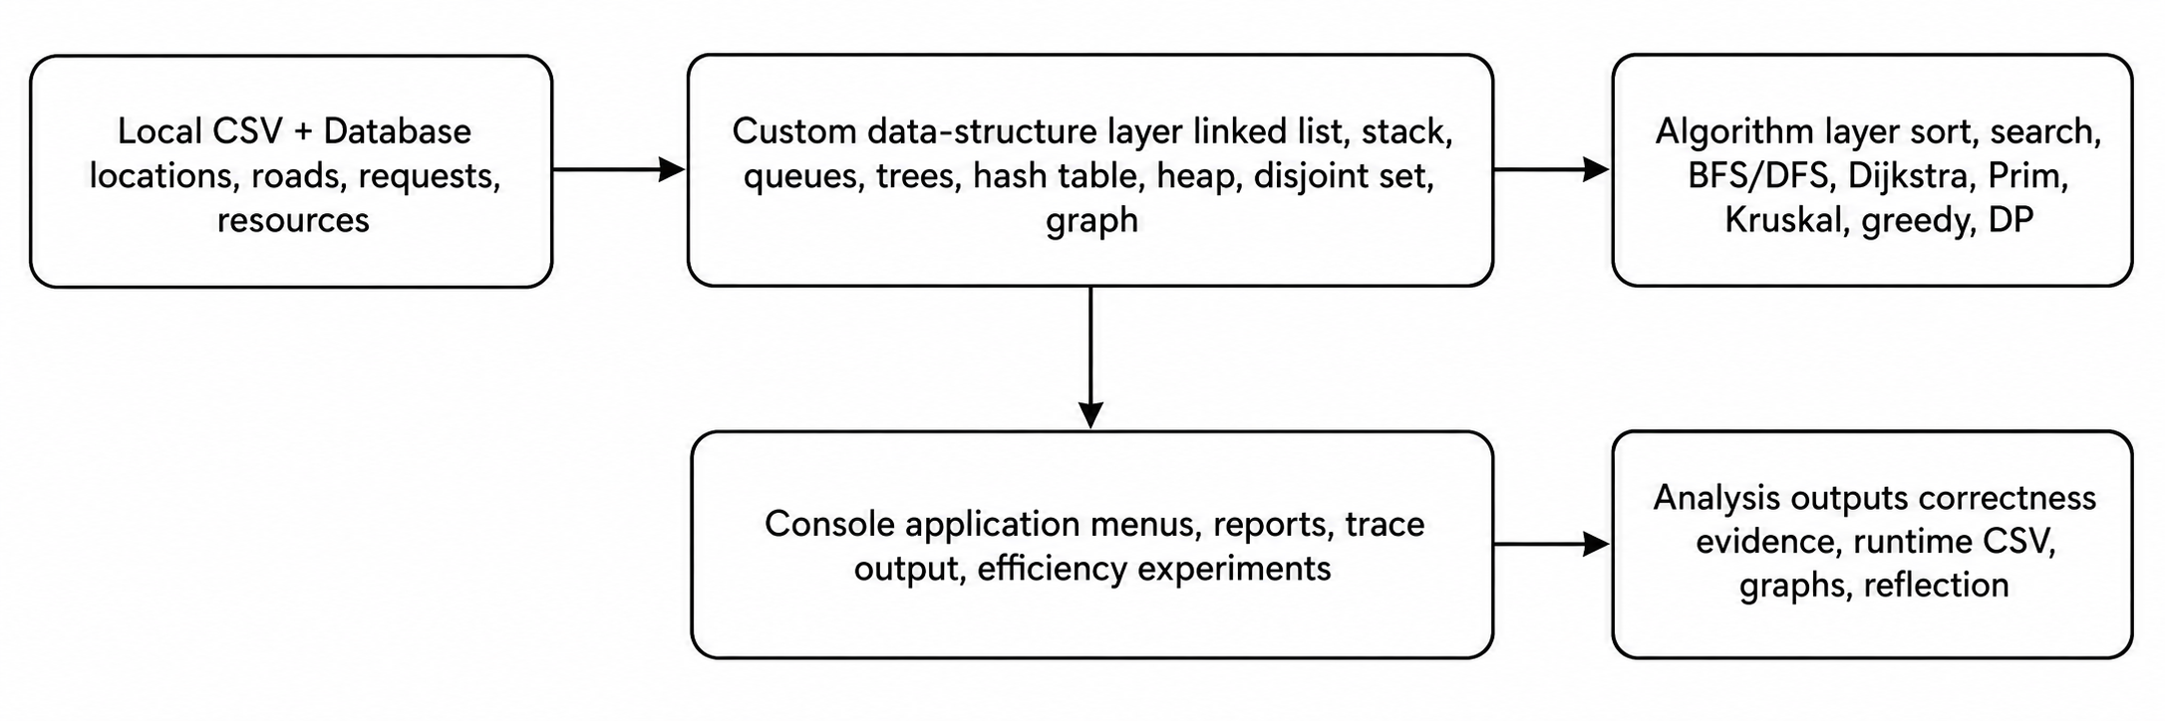

Course | DCIT 204/308 Data Structures and Algorithms I&II
Project mode | Team project: 12-16 students, with individual accountability
Recommended duration | 4 weeks
Recommended language | Java; database may be SQLite, MySQL or PostgreSQL
Final output | Working system, source code, database, tests, performance graphs, technical report and oral defense

1. Project overview
Students will build a realistic Ghana-context service operations platform that stores local operational data in a database, loads the data into custom-built data structures, applies algorithms to solve operational problems, verifies correctness, measures efficiency as input sizes increase, and presents evidence using tables and graphs. The recommended scenario is a Smart Service Operations Optimizer for a campus, municipality, hospital, logistics firm, ride dispatch service, waste-collection team, emergency-response team, or library-resource system in Ghana. Each team must select one local context and adapt the data, locations, service rules and constraints to that context.
This is not a UI-design project. The core marks are for correct data-structure implementation, algorithmic reasoning, empirical analysis, testing, database integration and clarity of explanation.

2. Industry scenario and Ghana localisation
Your organisation operates across a local Ghanaian environment. It receives service requests, stores them in a database, prioritises urgent jobs, assigns resources, finds routes between locations, monitors connectivity between zones, supports search and reporting, and evaluates algorithm performance.
Allowed local contexts | Example data students must adapt locally
University campus service hub | hostels, lecture halls, labs, shuttle stops, maintenance requests, lab-resource movement
Hospital or clinic operations | departments, patients, urgency levels, pharmacy requests, dispatch routes
Municipal waste or sanitation routing | communities, collection points, truck routes, priority areas
Courier or food delivery service | vendors, customer zones, riders, parcel priority, route network
Library or records office | book/request records, shelves, issue queues, search indexes

AI-resistance and localisation requirements
- Each team must use a Ghanaian local context and submit a short evidence note explaining how the dataset was obtained or constructed from local knowledge without exposing personal data.
- The dataset must include local names of places, routes, service categories and realistic constraints such as traffic, distance, urgency, operating hours, limited vehicles or staff.
- Each team must derive at least three algorithm parameters from member index numbers, for example priority weight, route penalty, hash-table size, random seed or budget constraint.
- Each team must include trace tables for selected algorithms. Generic code without trace evidence will be treated as incomplete.
- Every member must defend one data structure and one algorithm during the oral demonstration.

3. Core problem statement
Design and implement a system that answers operational questions such as the following:
- Which service request should be handled next under FIFO, urgency, and priority-based rules?
- What is the fastest route from one local location to another under weighted-road conditions?
- Which locations are reachable from the current dispatch point?
- Which subset of requests or resources can be selected under a budget, capacity or time constraint?
- How do alternative data structures and algorithms perform as the dataset grows?
- How can the system store records permanently and reload them for later analysis?

4. Minimum dataset and database requirements
Data entity | Minimum records | Required fields
Locations | 50 | locationId, name, area, type, latitude/longitude or local coordinates
Roads/edges | 100 | fromLocationId, toLocationId, distance, travelTime, roadConditionWeight
Service requests | 300 | requestId, source, destination, category, urgency, timeSubmitted, deadline, status
Resources | 30 | resourceId, type, homeLocation, capacity, availabilityStatus
Algorithm runs | 30 | runId, algorithmName, inputSize, timeNs, memoryKb, dateRun
Students may use CSV files to seed the database, but the final program must read from and write to the database. The database is not only storage; it must be part of the running system.

Suggested database schema
Table | Purpose
locations | Stores all nodes in the local service network.
roads | Stores weighted edges between locations.
service_requests | Stores jobs that will be queued, prioritised, searched and sorted.
resources | Stores vehicles, officers, staff, riders or assets that can be assigned.
algorithm_runs | Stores empirical runtime measurements and input-size metadata.
audit_events | Stores stack-based undo/audit operations and important system events.

5. Required system modules
Module | Required work
M1. Input-output and problem specification | Define computational problems, expected inputs, outputs, assumptions, constraints, and pseudocode/flowcharts for at least five major operations.
M2. Database and data loader | Create database tables, import CSV data, validate records, and reload data into custom structures.
M3. Custom data-structure library | Implement the required structures yourself: linked list, iterator, stack, queues, deque, priority queue, BST, red-black tree, B-tree, hash table, heap, disjoint set and graph.
M4. Searching and sorting engine | Implement linear search, binary search, selection sort, insertion sort, merge sort and quicksort; compare conditions and performance.
M5. Service scheduling engine | Use FIFO queue, circular queue, deque and priority queue/heap to model different dispatch rules.
M6. Indexing engine | Use BST, balanced tree and B-tree ideas to support search indexes over requests, locations or resources.
M7. Graph route engine | Represent the local network using adjacency list and adjacency matrix; implement BFS, DFS, Dijkstra, Prim and Kruskal.
M8. Optimisation engine | Implement at least one greedy algorithm and one dynamic programming algorithm; include one failure/counterexample for greedy.
M9. Testing and correctness evidence | Provide unit tests, trace tables, loop invariants or proof sketches for selected algorithms.
M10. Empirical efficiency lab | Measure time and memory for selected algorithms over varying input sizes and plot graphs.

6. Required data structures and exact evidence expected
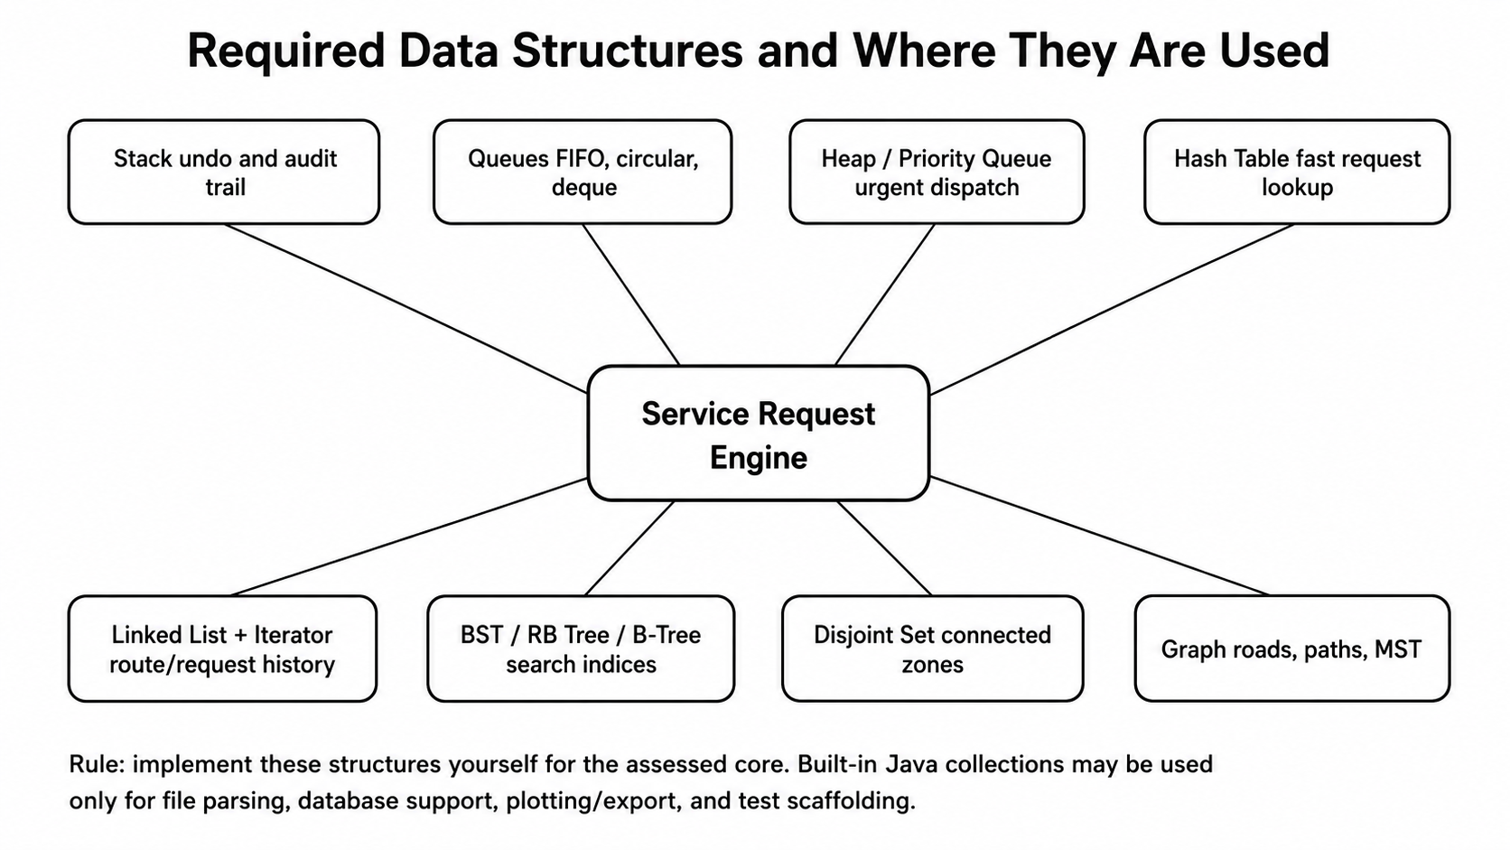
Data structure | Must implement | Evidence required
Dynamic array or array-backed list | insert, get, set, remove, resize | unit tests and resize trace
Singly or doubly linked list | addFirst, addLast, insertAfter, remove, iterator | diagram plus iterator demo
Stack | push, pop, peek, isEmpty | undo log or recursion simulation
Queue and circular queue | enqueue, dequeue, wrap-around handling | trace showing front/rear movement
Deque | addFront, addRear, removeFront, removeRear | urgent request insertion example
Priority queue / heap | insert, extractMin/Max, heapify | dispatch order trace
BST | insert, search, inorder traversal | search path and sorted inorder output
Red-black tree | insertion with rotations/recolouring OR clear simplified balanced-tree implementation | before/after rotation diagrams and height discussion
B-tree | node split and search OR database index simulation using B-tree pages | search trace and node split explanation
Hash table | put, get, remove, collision handling | collision statistics for different load factors
Set, map | custom set/map on top of hash table or BST | membership and lookup use case
Disjoint set | makeSet, find, union by rank/size, path compression | Kruskal connectivity trace
Graph | adjacency list and matrix | BFS/DFS/Dijkstra/MST results

7. Required algorithms and strategies
Topic | Required implementation | Required analysis/evidence
Foundations of algorithms | Pseudocode and input-output definition for core operations | clear preconditions, outputs and edge cases
Efficiency analysis | Primitive operation count for at least two algorithms | best, average and worst-case notes
Asymptotic notation | Big-O, Big-Theta and Big-Omega summary | relate theory to empirical graph
Brute force/exhaustive search | try all candidate assignments or route combinations for small n | show why it fails for large n
Linear and binary search | both implemented and tested | binary search precondition stated and tested
Selection and insertion sort | both implemented from scratch | stability and in-place discussion
Merge sort and quicksort | both implemented from scratch | recurrence/intuitive decomposition notes
Greedy algorithm | priority-based resource assignment or route choice | include a counterexample where greedy fails
Dynamic programming | knapsack-style request selection or route/budget optimisation | memoisation or tabulation table and reconstruction
BFS and DFS | reachable locations and traversal orders | trace table and graph diagram
Dijkstra | shortest path between two local locations | distance table and predecessor path
Prim and Kruskal | minimum connection network | MST edge list and total cost
Correctness and tractability | proof sketch for at least three algorithms | counterexample or limits discussion

8. Implementation constraints
- The core data structures listed in Section 6 must be implemented by the students. Built-in HashMap, TreeMap, PriorityQueue, Stack, ArrayDeque and similar classes are not allowed for assessed core logic.
- Built-in Java utilities may be used for file reading, printing, JDBC/database support, plotting export and unit-test scaffolding.
- Every custom structure must have tests for normal case, boundary case and invalid input case.
- The program must include a console menu or simple GUI that allows an examiner to run demonstrations without editing source code.
- The system must persist data to a database and must record algorithm experiment results in the database or exported CSV.
- The final report must include screenshots, trace tables and graphs, not only code listings.

9. Required performance experiments
The efficiency workflow is presented below
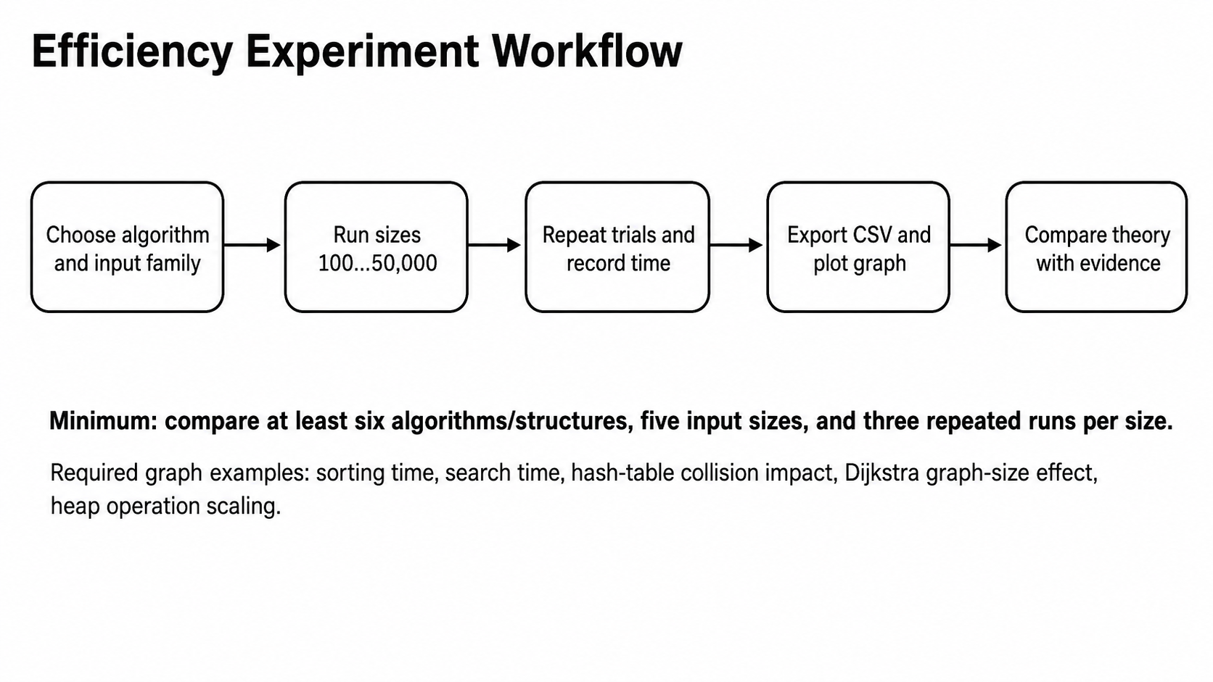
Experiment | Minimum input sizes | Expected graph
Search comparison | 100, 500, 1,000, 5,000, 10,000 records | linear vs binary search runtime
Sorting comparison | 100, 500, 1,000, 5,000, 10,000 requests | selection, insertion, merge, quicksort
Hash table load factor | 100 to 20,000 keys with different table sizes | load factor vs collision count/time
BST vs balanced tree | insert/search at multiple sizes | height and search time comparison
Heap priority dispatch | 100 to 20,000 requests | insert/extract operation time
Graph algorithms | 50, 100, 200, 500 locations/edges | BFS/DFS/Dijkstra/MST runtime
- Run each experiment at least three times and report the average runtime.
- Use the same machine for all experiments and state the machine specification.
- Export results to CSV and plot line graphs. Excel, Python or Java plotting libraries may be used.
- Explain any mismatch between theoretical complexity and observed runtime.

10. Correctness and testing expectations
Evidence type | Minimum requirement
Unit tests | At least 40 tests across data structures and algorithms.
Trace tables | At least six trace tables: binary search, insertion sort, merge sort/quick sort, Dijkstra, Kruskal/Prim, DP.
Proof sketches | At least three: loop invariant for search/sort, induction/recursion proof, greedy or DP correctness idea.
Counterexamples | At least two: one greedy failure and one invalid precondition such as unsorted binary search input.
Edge cases | empty structure, single element, duplicate keys, disconnected graph, unreachable path, queue full/empty, hash collision.

11. Final report structure
- Cover page with title, team members, local Ghana context and selected organisation/problem.
- Problem statement, assumptions, input-output definitions and system boundaries.
- Dataset description, data dictionary and database schema.
- System architecture and module design.
- Data-structure implementation section with diagrams and explanations.
- Algorithm implementation section with pseudocode and selected Java snippets.
- Correctness evidence: trace tables, invariants, proof sketches and edge-case tests.
- Performance analysis: method, input sizes, raw results tables, graphs and interpretation.
- Database integration evidence: schema, sample records, screenshots and run logs.
- Responsible algorithm selection: when the chosen algorithm is appropriate and when it is not.
- Individual contribution statement and oral-defense preparation notes.
- References and appendices.

12. Required submission items
Item | Format | Notes
Source code | ZIP or Git repository export | Include README and run instructions.
Database scripts | SQL files and database seed data | schema.sql and sample CSV files required.
Technical report | PDF and DOCX | Use the report structure above.
Performance results | CSV plus plotted graphs | Keep raw timings, not only screenshots.
Demonstration video | 5-8 minutes | Show database load, core algorithms, tests and graphs.
Oral defense | live or recorded | Each student must explain one structure and one algorithm.

13. Recommended milestones
Milestone | Expected completion
M1: Local context and dataset plan | Problem statement, data dictionary and schema draft
M2: Data-structure library | Core structures implemented with unit tests
M3: Searching and sorting | Search/sort algorithms with correctness traces
M4: Graph and optimisation | Graph algorithms, greedy and DP implemented
M5: Database integration | Load/save/search data through database
M6: Efficiency study | CSV results and graphs produced
M7: Final defense | Report, code, database and demo ready

14. Assessment rubric
Area | Marks | What earns high marks
Local problem design and data quality | 10 | Realistic Ghana context, clean data dictionary, strong input-output thinking.
Data-structure implementation | 20 | Correct custom implementations, edge-case handling, clear diagrams and tests.
Algorithm implementation | 20 | Correct search, sort, divide-and-conquer, graph, greedy and DP algorithms.
Database integration | 10 | Persistent storage, SQL schema, import/export and clean separation from algorithms.
Correctness and testing | 15 | Trace tables, proof sketches, invariants, unit tests and counterexamples.
Efficiency analysis and graphs | 15 | Reliable experiments, varying input sizes, graphs and theory-to-practice interpretation.
Report quality and oral defense | 10 | Clear writing, screenshots, individual accountability and confident explanation.
Total | 100

15. Academic integrity and AI-resistance controls
- Every team must use a distinct Ghanaian local context and dataset. Copying a generic online logistics, hospital or campus example without localisation will lose marks.
- The report must include team-specific trace outputs generated from the team dataset and index-number parameters.
- The examiner may ask students to modify a priority rule, add a new location, change a hash table size, or rerun an algorithm live.
- Students must submit a short development log showing weekly progress, challenges and decisions.
- Generic explanations without code evidence, tests, runtime data and database screenshots will not be accepted as complete.
- All AI assistance, if used, must be acknowledged, and students must be able to explain and modify their own implementation (with the supporting prompts used).

16. Suggested references
- Cormen, Leiserson, Rivest and Stein, Introduction to Algorithms, MIT Press.
- Sedgewick and Wayne, Algorithms, Princeton University.
- Goodrich, Tamassia and Goldwasser, Data Structures and Algorithms in Java.
- Lewis, DePasquale and Chase, Java Foundations: Introduction to Program Design and Data Structures.
- MIT OpenCourseWare: Introduction to Algorithms.
- OpenDSA: Data Structures and Algorithms learning materials.
- Stanford CS166 and Princeton Algorithms public-lecture materials on advanced tree and graph intuition.

17. Attendance
All students must sign-in/out during team meetings.

